Exercising with Myositis

Myositis is the term for the collection of inflammatory muscle conditions where weakness is usually seen as a result of the disease process in the muscles. Historically it was thought that exercising and strengthening may worsen the disease. However, more recently research has consistently shown that exercise can be done, even in active disease, and helps with the recovery of muscle strength and function.

We are keen that all of the people with myositis under our care have a regular home exercise programme. Not everyone will manage the same level of exercise, but the following exercises; performed at whatever level you can manage have been shown to help.

Ideally your exercises shown performed daily; or at a minimum 5 days per week. Start at a low intensity, or a low number of repetitions of each exercise, and then gradually increase intensity over a number of weeks or months. If possible, have a physiotherapist assess muscle strength and function at baseline.

Maintaining a regular exercise habit can be a challenge and therefore an exercise diary can help to keep up the motivation. A diary can be on paper, on your computer, or you could try a bespoke smart phone application to record exercise activities.

The exercise in this booklet are intended to help the specific issues myositis may give you, in addition to these where able we’d recommend regular walking exercise and an option to find an exercise that you enjoy doing – either by yourself, or even better in a regular group session.

A vast majority of people with myositis tolerate these exercise programmes very well, however clinical experiences indicate that reduced muscle strength or increased pain have occurred in rare cases. If you have previously experienced these symptoms after moderate physical activities, start on an even lower exercise dose than suggested in these programmes and be sure to have frequent follow-ups and measure strength regularly.

This booklet contains 2 separate exercise programmes. The first is from the internationally renowned research team in Sweden and is good to work on for diagnoses of dermatomyositis, polymyositis, anti-synthesase syndrome, IIM, overlap diagnoses and necrotising myopathy. The second programme is specifically for diagnoses of IBM – inclusion body myositis and has been recommended by research in Australia and ratified by the team in Sweden. Whilst other exercise programmes may be out there, these are the best-evidence based for people with myositis.

Idiopathic inflammatory myopathies resistive home exercise programmes

1. All diagnoses except IBM

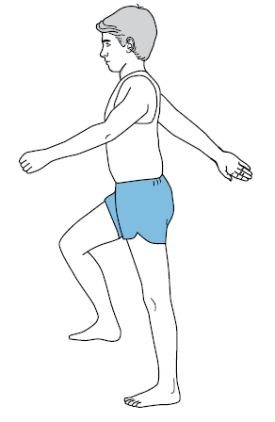Warm up: use a step that is approx. 20cm in height, step up and down leading first with right leg for 1 minute then change to left leg and repeat for another minute. If you are struggling with your balance then use something to hold onto if not, then swing your arms as if you were marching.

1a. To increase range of movement in the arms use a pulley. In sitting, pull left arm down to increase range of right then pull down with right. During each movement keep the elbows moving in front of you. Repeat 10x on each arm

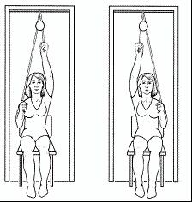

1b. Repeat the above exercise moving the elbows out to the side. Repeat 10x each arm

2. To increase grip strength, using one hand at a time squeeze the handles of the pulleys as tight as you can. Hold for 5 seconds. Repeat 10x on each hand

3. To improve strength in your thighs, sit on a chair or the bed with your thighs supported. Tighten thigh muscles of one leg then straighten knee, hold for 5 secs and lower. Repeat 10x on each leg. As you get stronger add a weight around the ankle and repeat. 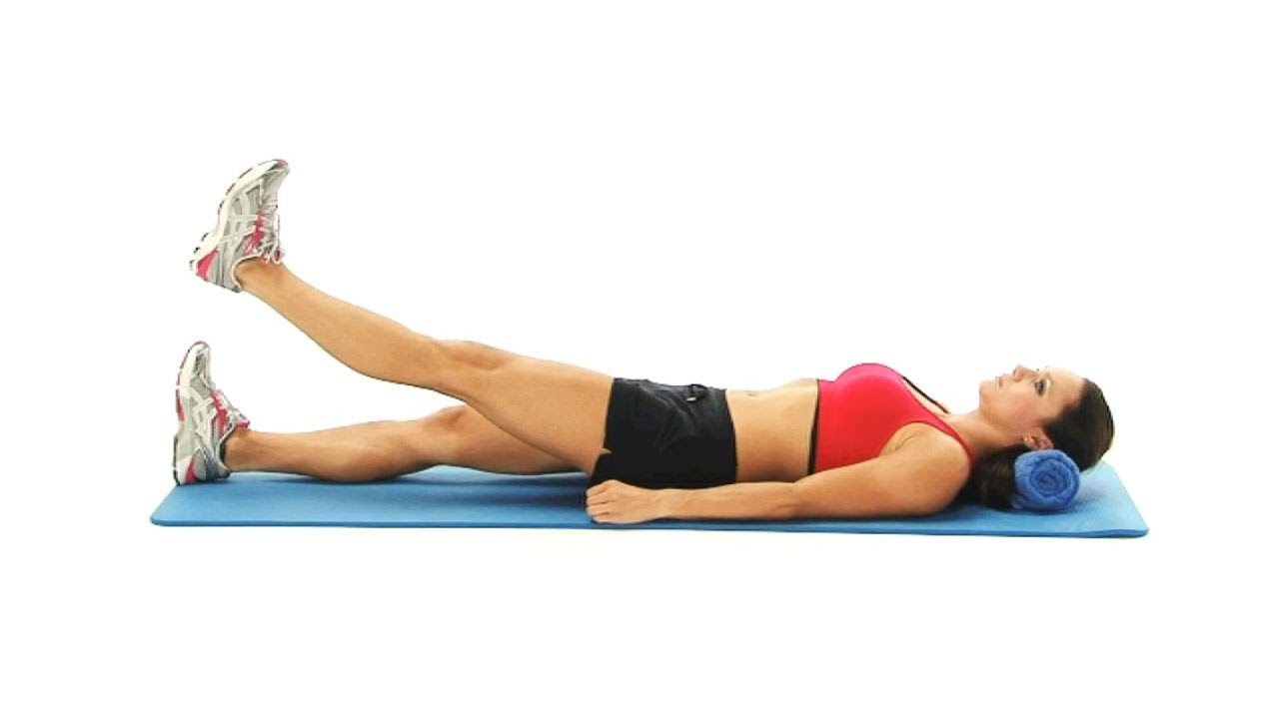

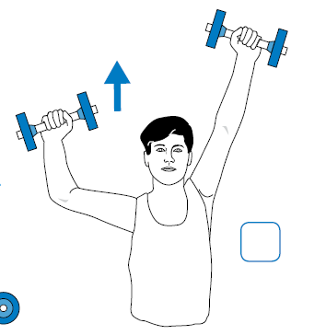4. To increase upper limb strength sit down, bend your elbows, then straighten your arms above your head one at a time. Use small weights eg dumbells or can of beans or weight cuff around your wrist to make this harder. Repeat 10x on each arm

5a. To increase range of movement of shoulder, place one hand on the back of your neck and lift the elbow out to the side as far as it will go. Change arms. Repeat 10x on each arm

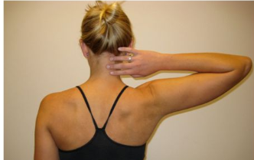

5b. Place one hand on opposite shoulder and lift elbow upwards as far as it will go change arms. Repeat 10x on each arm.

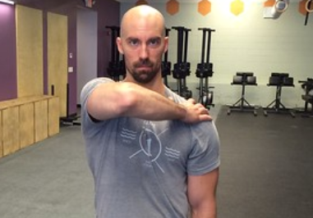

5c. Place your hand on the lower part of your back and move it or lift it away from your back as far as you can without leaning forward. Repeat x10 each arm.

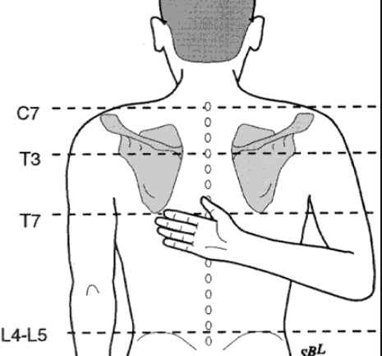

6. To strengthen lower limbs. Lie down on the floor or a bed and bend both knees. Squeeze buttocks together and lift bottom / pelvis up as high as you can. Hold for 5 secs then slowly lower. . Repeat x10

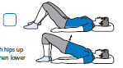

7. To strengthen trunk. Lie down on the floor or bed and bend both knees. Place your hands on your thighs, tuck your chin in, tighten abdominal muscles, breathe out and reach down towards your knees, lifting shoulders from floor or bed. Hold position, breath in and on the breath out lower back to the floor. Repeat x10

IMAGE FROM SRFT RESOURCES

8. To strengthen hip muscles. Lie down on your back, lift one straight leg approx. 30cm from floor / bed. . Repeat x10 each leg

IMAGE FROM SRFT RESOURCES

9. To strengthen hip muscles lie on your side bend the bottom knee to help keep your balance and keep top leg straight. Tighten abdominal muscles and lift top leg approx. 30cm towards ceiling, leading with your toes. Repeat x10 turn over onto opposite side and repeat x10

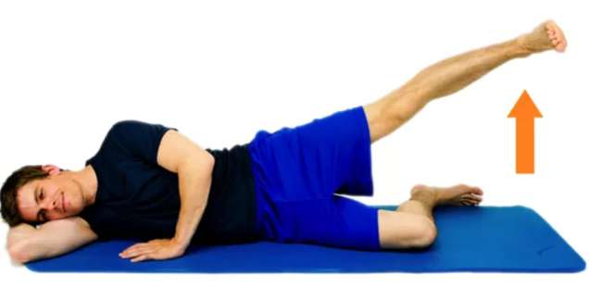

10. To stretch trunk and shoulder lie on your back, place both arms above your head and stretch right arm and right leg as far as you can in opposite directions, swap sides and repeat x10 each.

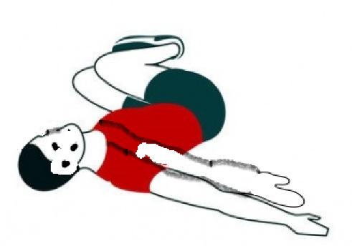

11. To stretch hamstrings, sit down on a bed with one straight leg on the bed and the other foot on the floor. Keeping knee straight, sit up as tall as you can, keeping your back straight and hold for 20 secs. . Repeat x 2-3 each leg.

IMAGE FROM SRFT RESOURCES

12. To stretch your calf muscles, stand up with one leg bent in front, the other behind keeping the knee straight and with both feet facing forwards. Lean forwards with hands resting on something solid and that will not move as you increase the lean for example a wall or chair or kitchen work top. Keep your back heel on the floor all of the time. Hold for 20 secs and repeat x 2-3 on each leg.

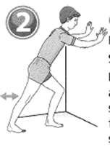

13. To stretch neck muscles in standing or sitting, move your head to the side trying to get your ear onto your shoulder. Keep your eyes and face looking forwards (it may be useful to do this in front of a mirror). Stretch the opposite hand down towards the floor. Hold for 20secs and repeat x 2-3 each side.

IMAGE FROM SRFT RESOURCES

Exercise programme 2: IBM (Inclusion Body Myositis)

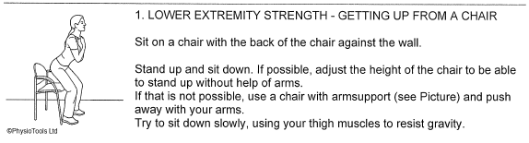

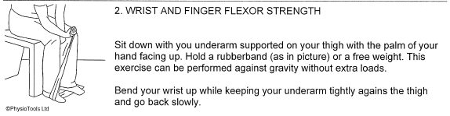

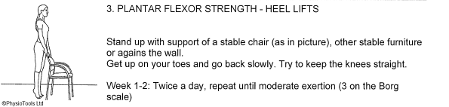

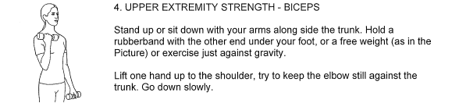

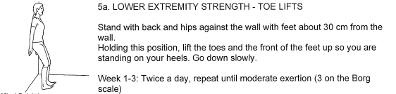

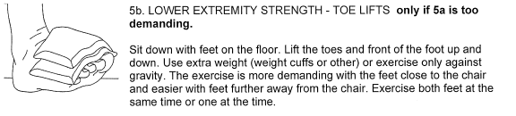

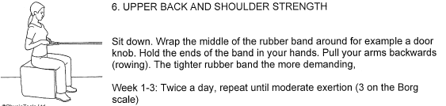

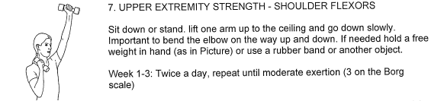

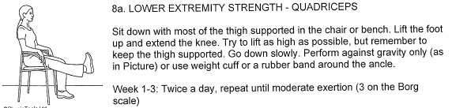

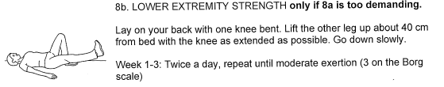

In addition to these exercises from the research in Australia, a programme of hand strengthening may be required. Please request our hand strengthening exercise programme booklet and consider referral to our Hand Therapy team for specific advice and individual modifications.